**Title: Four-Legged Bluetooth- Controlled Spider Robot**

**ABSTRACT**

The Four-Legged Spider Robot is an agile, Bluetooth-enabled robotic platform designed for educational, research, and hobbyist applications in mobile robotics. Mimicking the movement of a spider, this robot is capable of forward, backward, and rotational locomotion across diverse terrains using a coordinated gait mechanism. It serves as an excellent introduction to real-time control systems, embedded electronics, and biomechanics-inspired robotics.

At the heart of the system lies an Arduino Nano microcontroller, which receives directional commands wirelessly via an HC-05 Bluetooth module from a smartphone application such as Serial Bluetooth Terminal. Based on the commands, the microcontroller drives four gear motors through a custom leg linkage mechanism, enabling smooth and realistic locomotion. The robot is powered by a compact 18650 Li-ion battery pack, making it both portable and long-lasting for extended demonstrations.

The mechanical frame is built using lightweight 3D-printed components, ensuring structural integrity while minimizing weight. Its modular architecture allows easy upgrades and integration of additional sensors such as obstacle detectors, line followers, or cameras. The design also supports future enhancements like autonomous navigation or AI-based control.

By combining simple electronics, mobile control, and biomimetic movement, this spider robot offers a compelling platform for STEM education, showcasing core principles of robotics, wireless communication, and mechanical design in a hands-on, interactive manner.

### 

### **FIELD OF INVENTION**

The present invention relates to the field of mobile robotics and embedded systems, particularly to Bluetooth-controlled quadruped robots that utilize bio-inspired leg mechanisms for motion. This invention falls under the domain of robotics engineering, wireless communication, and microcontroller-based control systems.

More specifically, the invention focuses on the design and development of a compact, wireless-controlled, four-legged robotic platform that can navigate diverse terrains using realistic locomotion patterns. It combines Bluetooth-based remote control, Arduino-based motor actuation, and mechanical leg linkage systems to achieve dynamic movement. The system also supports applications in educational robotics, research in bio-mechanical locomotion, and low-cost mobile robot development.

This invention is applicable in areas such as:

* Robotics learning and prototyping in STEM education
* Motion analysis and gait control in bio-inspired robotics
* Remote-controlled exploration in constrained or uneven environments
* Modular platforms for future autonomous navigation research

### **BACKGROUND OF THE INVENTION**

In recent years, the field of robotics has seen significant advancements, especially in the development of mobile robots capable of navigating complex environments. Among these, legged robots have gained substantial interest due to their ability to traverse uneven terrain more effectively than wheeled robots. Inspired by the movement of biological organisms, quadruped (four-legged) robots offer enhanced stability, mobility, and adaptability across a variety of surfaces.

Traditional legged robots, however, are often complex and expensive, limiting their accessibility for educational and prototyping purposes. At the same time, the growing popularity of Arduino-based systems and Bluetooth modules has opened new possibilities for creating low-cost, wirelessly controlled robotic platforms. These technologies allow students, hobbyists, and researchers to build and control robots using readily available tools and smartphones.

Despite the availability of components, there is a gap in compact, user-friendly legged robot designs that can demonstrate practical applications of embedded systems, wireless communication, and motion control. The need for such a system becomes more relevant in educational institutions where hands-on learning is essential for understanding real-world engineering concepts.

The Four-Legged Spider Robot addresses this need by integrating a simple yet efficient Bluetooth-controlled locomotion system with an Arduino-based platform. It is designed to be compact, portable, and functional on various terrains, making it ideal for both educational demonstrations and personal experimentation in the field of robotics.

### **SUMMARY OF THE INVENTION**

The invention provides a four-legged spider-like robotic system that is controlled wirelessly via Bluetooth communication, enabling directional movement through commands sent from a smartphone. The robot uses an Arduino Nano microcontroller as the core processing unit, which interprets control signals and operates four gear motors that drive the mechanical legs.

The robot is powered by a rechargeable 18650 Li-ion battery pack, offering portable energy for untethered mobility. A HC-05 Bluetooth module is integrated for real-time wireless control, typically using the Serial Bluetooth Terminal app. The system is programmed to respond to basic directional inputs like forward, backward, left, and right, allowing smooth movement across various surfaces.

The mechanical design consists of a lightweight 3D-printed chassis and articulated leg mechanisms, which simulate spider-like locomotion. This design ensures improved balance, adaptability, and terrain handling compared to traditional wheeled robots.

This invention simplifies the implementation of legged robotic movement using accessible components and basic embedded programming. It is particularly suited for educational purposes, robotics training, and low-cost research platforms. Furthermore, the modular and open-ended nature of the system allows for future enhancements such as:

∙ Autonomous navigation

∙ Obstacle avoidance

∙ Sensor integration (e.g., ultrasonic, IR)

∙ Voice or gesture control

**SPECIFICATION**

∙ The system uses 4 geared DC motors (typically 6V 150–200 RPM) to drive the leg mechanisms of the spider robot, enabling it to move forward, backward, and rotate left/right. These motors provide adequate torque and speed for crawling on various surfaces.

∙ The robot follows a quadruped locomotion mechanism, where the coordinated motion of four legs mimics a spider-like gait, enhancing balance and movement across both smooth and uneven terrain.

∙ An Arduino Nano microcontroller acts as the central control unit of the robot. It interprets Bluetooth signals and translates them into motor control instructions. It is compact, easy to program (in Embedded C), and ideal for robotic applications.

∙ A HC-05 Bluetooth module is used to receive wireless commands from a smartphone. The robot connects to apps like Serial Bluetooth Terminal, allowing directional control via predefined character commands (e.g., F, B, L, R).

∙ The motor control is managed directly via Arduino digital pins or through an optional L298N motor driver module for better current handling and bidirectional control of DC motors.

∙ The robot is powered by a 3-cell 18650 Li-ion battery pack, supplying ~11.1V to the motors and controller. A DC-DC converter is used if voltage regulation is needed to protect Arduino and other low-voltage components.

∙ The mechanical structure is made of lightweight, 3D-printed materials or acrylic, designed for portability and structural stability. The leg design allows the robot to adapt to terrain changes effectively.

∙ The entire system is assembled using jumper wires, screws, and connectors, making it modular and easily serviceable. Additional components like LEDs, sensors, or buzzers can be integrated for future expansion.

∙ The robot can be operated through a smartphone app, eliminating the need for additional hardware like remotes or computers, making it user-friendly and efficient for demonstrations.

∙ Designed for educational, demonstration, and research purposes, the robot supports further customization such as sensor integration (e.g., obstacle avoidance) or autonomous movement algorithms.

**DESCRIPTION**

The Four-Legged Bluetooth-Controlled Spider Robot is a compact, mobile robotic system designed to mimic spider-like locomotion while being controlled remotely via Bluetooth. It integrates key principles of embedded systems, wireless communication, and mechanical motion, making it a suitable platform for educational, research, and hobbyist purposes.

The robot’s movement is enabled by four geared DC motors, each responsible for actuating a leg or a pair of legs through a mechanical linkage system. These legs simulate the gait of a spider, allowing the robot to move forward, backward, and rotate in place. The chassis is lightweight and fabricated using 3D-printed materials or durable plastic, ensuring structural stability without adding unnecessary weight.

At the core of the system lies an Arduino Nano microcontroller. It processes incoming commands received via a Bluetooth module (HC-05) paired with a smartphone. Using a mobile application such as Serial Bluetooth Terminal, users can send directional commands in the form of characters (e.g., F, B, L, R) which the Arduino interprets to control the motion of the robot.

The power supply is managed through a 3-cell 18650 Li-ion battery pack, providing adequate voltage and current to run both the motors and the control electronics. A DC-DC buck converter may be included to regulate voltage where necessary, ensuring safe operation of the microcontroller and Bluetooth module.

The electronic components are connected using jumper wires, while the mechanical parts are fastened using screws and nuts. The robot is designed to be modular, allowing for future upgrades such as integration of sensors (ultrasonic, IR), obstacle avoidance, or autonomous navigation features.

This robot operates efficiently on various surfaces, thanks to its bio-inspired design and low center of gravity. Its user-friendly design, low cost, and educational value make it an ideal tool for demonstrating robotics concepts, programming logic, and real-time wireless control in classroom or laboratory settings.

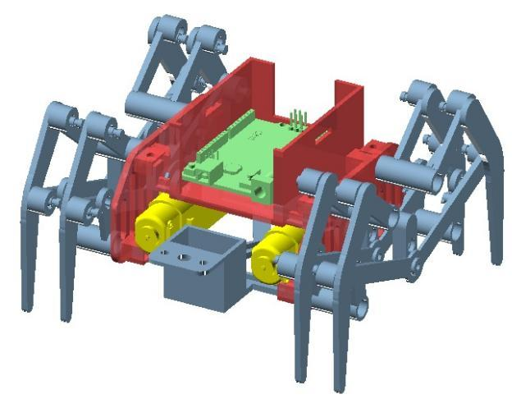 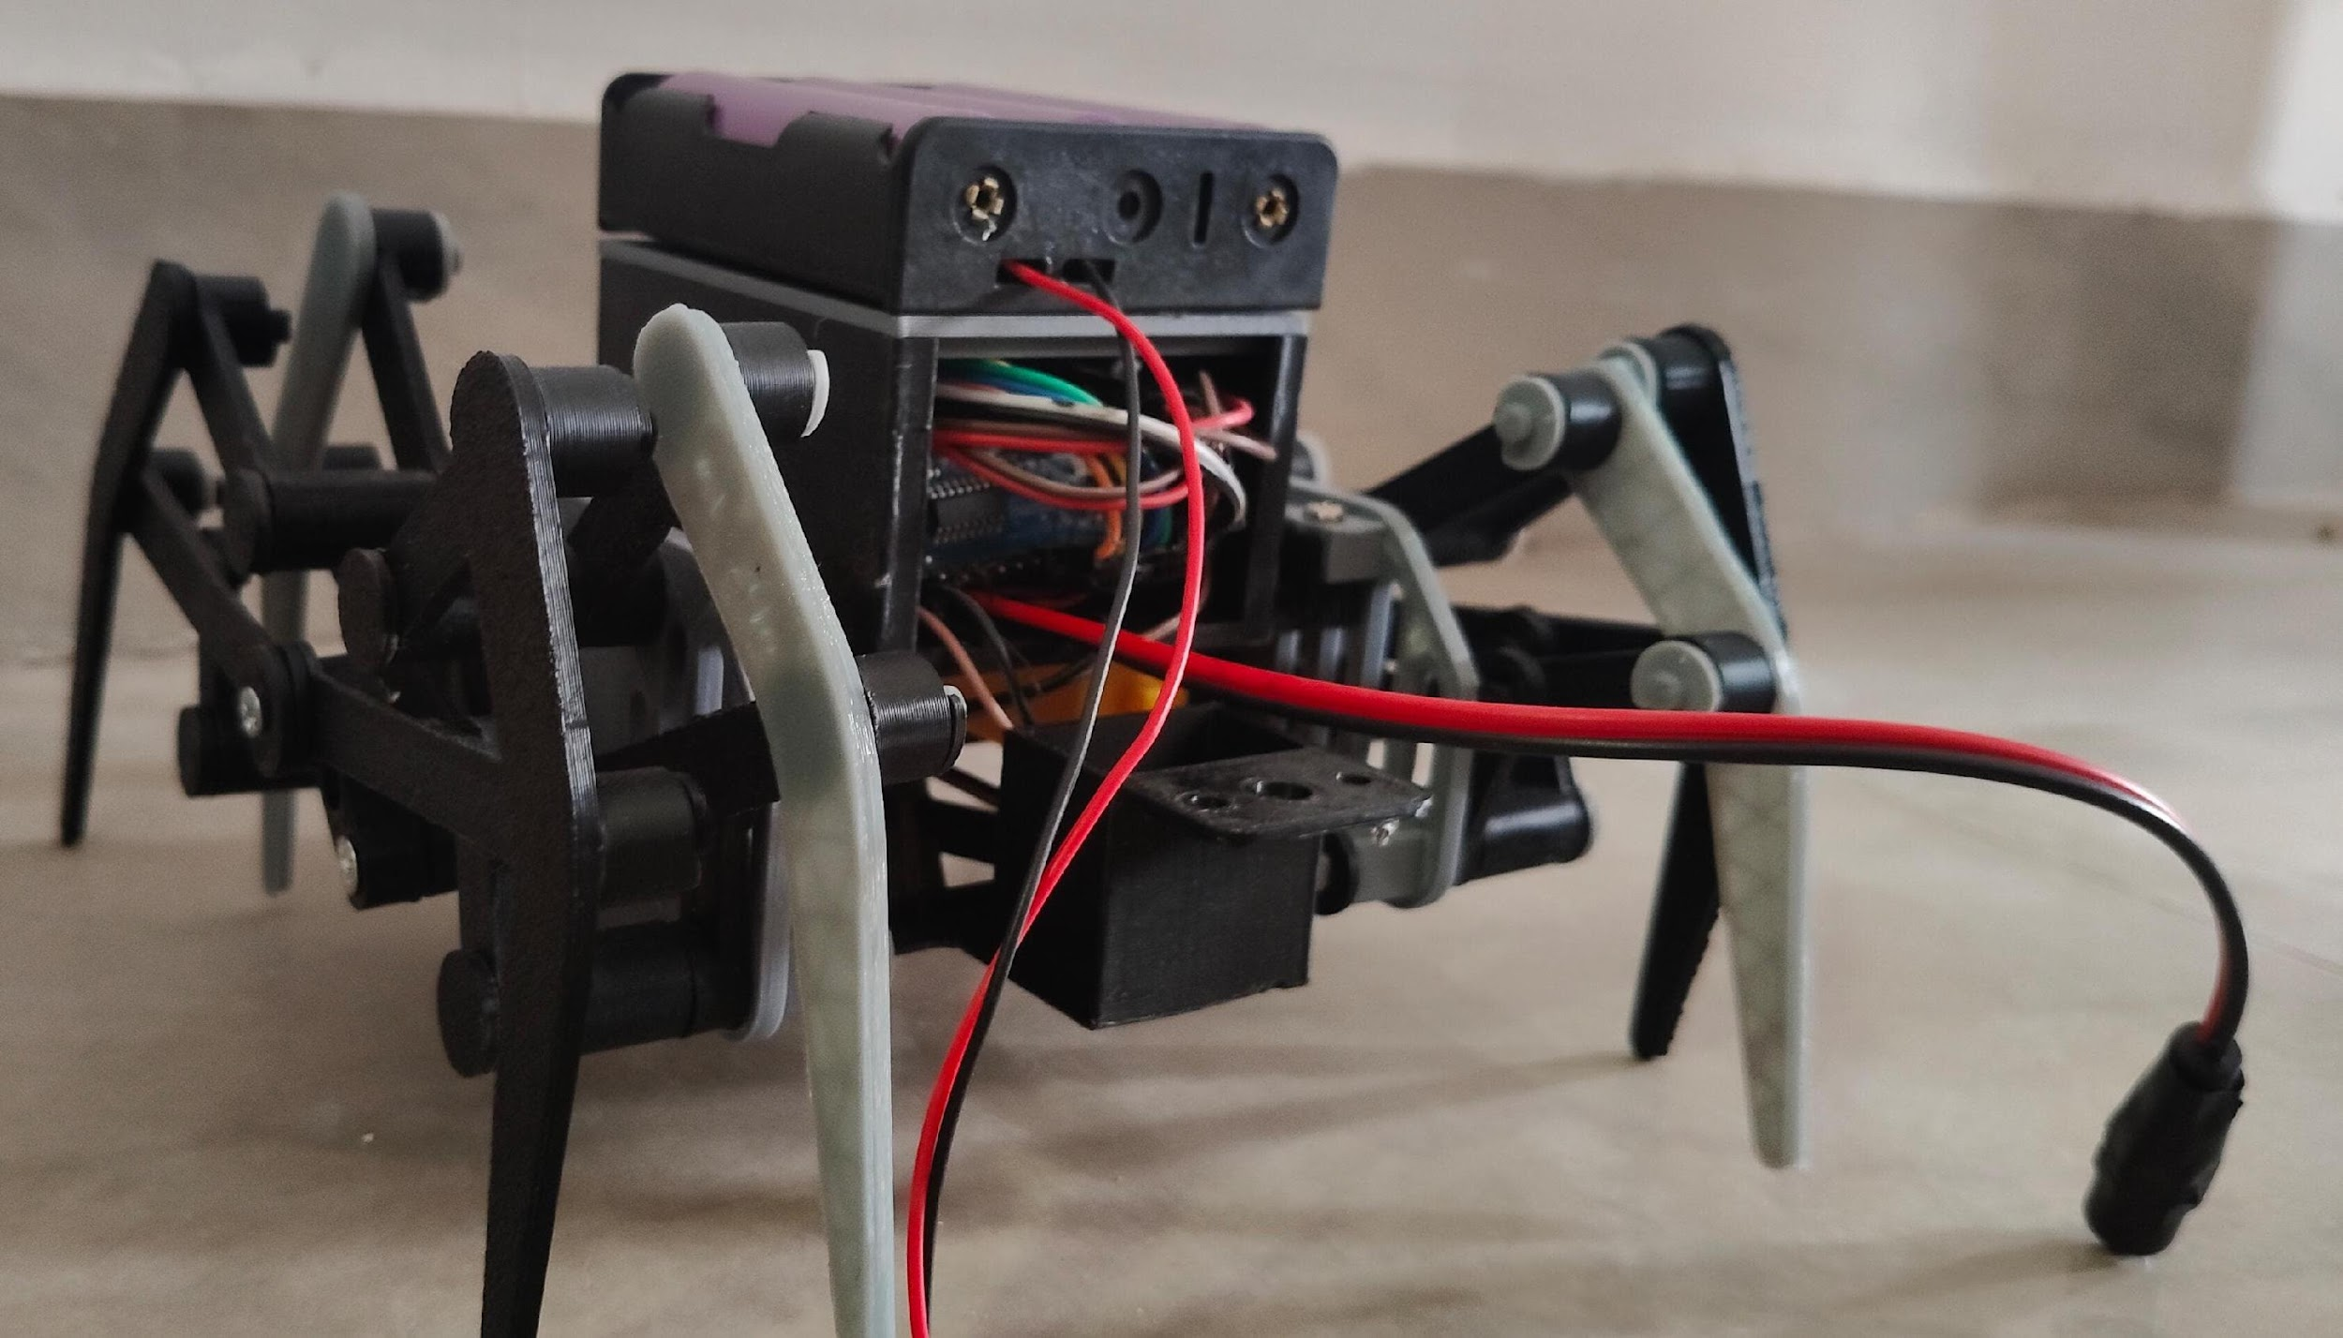

3D image of Four Legged Spider 2D image of Four Legged Spider

### 

### **WE CLAIM**

∙ Claim 1: A Bluetooth-controlled quadruped robot comprising a lightweight mechanical body with eight legs actuated by only two BO motors (60 RPM), controlled via an Arduino Nano and driven through an L298N motor driver module.

∙ Claim 2: The robotic system of claim 1, wherein a mechanical linkage system is used to distribute the rotational motion of two motors to coordinate the movement of all eight legs, enabling stable forward, backward, and rotational movements.

∙ Claim 3: The robotic system of claim 1, wherein an HC-05 Bluetooth module facilitates wireless communication with a smartphone using the Serial Bluetooth Terminal app to control direction through simple character commands.

∙ Claim 4: The robot of claim 1 is powered by a power supply consisting of three 18650 lithium-ion batteries mounted in a dedicated battery holder, offering sufficient power for both logic and motion control systems.

∙ Claim 5: The system of claim 1 utilizes an Arduino Nano as the central controller, programmed to interpret Bluetooth input and regulate the motor driver to control motion precisely and responsively.

∙ Claim 6: The robot of claim 1 features a compact and portable chassis made from modular and lightweight materials, supporting the entire mechanical and electronic assembly securely while maintaining agility.

∙ Claim 7: The robot of claim 1 is designed to move efficiently across a variety of indoor and flat surfaces, making it suitable for both demonstration and functional use cases.

∙ Claim 8: The robotic system of claim 1 can serve multiple purposes, including but not limited to: a smart toy, a personal robotic assistant, an educational laboratory model, and a foundation for industrial automation, depending on future upgrades.

∙ Claim 9: The robotic system of claim 1 is modular in design, allowing future enhancement with features such as obstacle detection, environmental sensing, gesture or voice control, and autonomous navigation.